**Hands-on .NetCore 3.0**

**Csv To Html**

Table of Contents

Project Setup 2

Using Readline 2

CSV File 3

Converting CSV to HTML 3

Run the App 4

# Project Setup

We’ll be creating a console app so setup the structure as following

First create the folder and then CD to it and finally create a console app using command **dotnet new console**

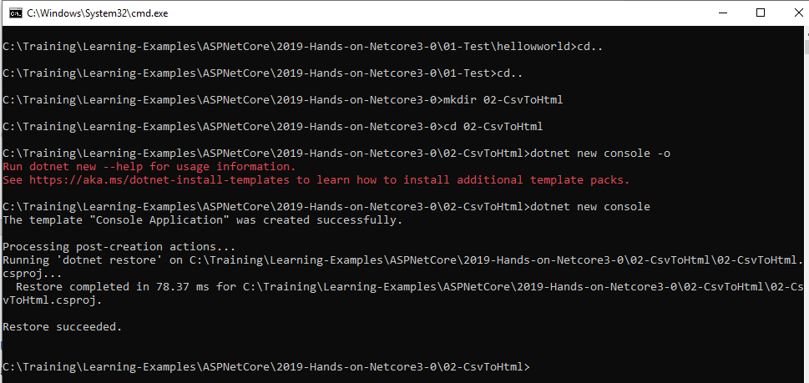

Open the project in VS Code

Issue command **dotnet run** to make sure that the app is running fine

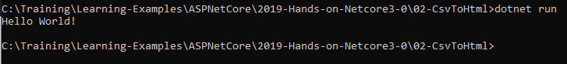

Or at the top, click menu item **Debug** and then click **Start Debugging** or **press F5** on your keyboard.

# Using Readline

We’ll display a message to the user and then ask the user to press any key to see the message. Update the Program.cs with the following and then run the app with **dotnet run** command.

static void Main(string[] args)

        {

            Console.WriteLine("Press any key to see a message...");

            Console.ReadLine();

            Console.WriteLine("Hello World!");

        }

# CSV File

Next we’ll create a csv file. Go to the file explorer area in VS Code, right click and then click New File from the menu. Name the new file test.csv. Open the csv file.

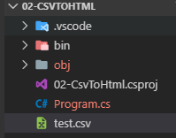

Update the file with the following content

firstname,lastname,company,email

John,Smith,Test,john.smith@test.com

Mark,Johnson,Acme,mark.johnson@acme.com

Jay,Johnson,WhyNot,jay.johnson@whynot.net

# Converting CSV to HTML

We are reading the csv file and will build the html out of it. For this, replace the contents of the **Main method** with the following, the best would be to type to learn.

* make sure to add the using references.
* Each command is described by the comment
* We are reading the file using StreamReader and then iterate the lines to build the final html
* The last two lines outputs the built html to console and also writes to the file.
* And finally we are closing the file

using System;

using System.Collections.Generic;

namespace _02_CsvToHtml

{

class Program

{

static void Main(string[] args)

{

//test csv path

var filePath = @"C:\Training\Learning-Examples\ASPNetCore\2019-Hands-on-Netcore3-0\02-CsvToHtml";

//file to read

var file = @"test.csv";

//will tell us the number of lines in the csv file

var counter = 0;

//using the stream reader, we'll read line by line from the file

var line = "";

//since we are converting the comma separated file into HTML, create a string so that we can write the data as html

var htmlString = "<h1>Users</h1>\n<table border=1>\n";

//read the file using the stream reader

System.IO.StreamReader csvFile = new System.IO.StreamReader(filePath + @"\" + file);

//use a while loop to read the lines

while((line = csvFile.ReadLine()) != null)

{

//split the line

string[] tempLine = line.Split(',');

//add the row

htmlString += "\t<row>\n";

//first row in the csv is the header so read the content in create columns;

foreach(var data in tempLine)

{

if(counter == 0)

{

//table header

htmlString += "\t\t<th>" + data + "</th>\n";

}

else

{

//table data

htmlString += "\t\t<td>" + data + "</td>\n";

}

}

//end the table row

htmlString += "\t</row>\n";

//increment the counter

counter++;

}

//end the table

htmlString += "</table>";

//write the string

Console.WriteLine(htmlString);

//write to an external file as well

System.IO.File.WriteAllText(filePath + "\\test.html", htmlString);

//close the file

csvFile.Close();

//ask the user to exit

Console.WriteLine("");

Console.WriteLine("Press any key to exit");

Console.ReadLine();

}

}

}

# Run the App

Use **command dotnet** run to run the app

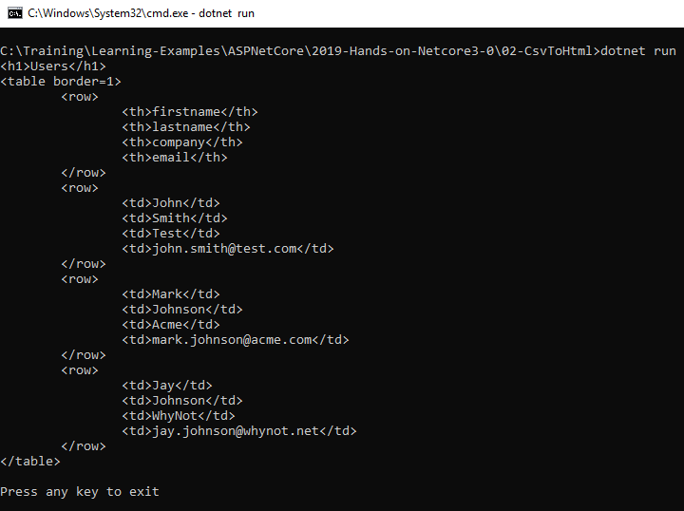

And the solution explorer showing the final test.html file

